Adding Laravel User Profiles
Part 37 of 48 in API Driven Development With Laravel and VueJS

Dan Pastori January 11th, 2018
#Laravel
Manage, Deploy and Measure Features At Scale With Feature Flags From CloudBees. Start A Free Trial.ads via Carbon
The last few tutorials, we’ve opened up public data for the cafes. We started opening up a few routes with larval https://serversideup.net/public-private-api-laravel/, then explored VueJS Route Security and Authentication and finally implemented some navigation guards. In this tutorial we will go through the process of

Step 1: Define Data To Collect
When building our user infra-structure I like to really tailor the content we collect to be specific to the app. This way we can expand the app to provide more value for the user. For example, if the user lives in Los Angeles, CA, they can be alerted of new cafes in the area, or if their favorite brew method is added to a cafe, they can be notified.
Other cool uses for user profiles will be to recommend cafes to friends in the future. This will start to build a coffee community. Our user profile page will allow the user to enter the following information:
- Favorite type of coffee
- Flavor notes
- Whether their profile should be public/private
- Location

Step 2: Make User Profile Migrations
The first step in the process is to add the appropriate MySQL Columns to hold the data we need. To do this, make a migration that expands the user fields:
php artisan make:migration added_user_profile_fields --table=users
Then add the following content to the migration:
/**
* Run the migrations.
*
* @return void
*/
public function up()
{
Schema::table('users', function (Blueprint $table) {
$table->text('favorite_coffee')->after('avatar');
$table->text('flavor_notes')->after('favorite_coffee');
$table->boolean('profile_visibility')->default('1')->after('flavor_notes');
$table->string('city')->after('profile_visibility');
$table->string('state')->after('city');
});
}

/**
* Reverse the migrations.
*
* @return void
*/
public function down()
{
Schema::table('users', function (Blueprint $table) {
$table->dropColumn('favorite_coffee');
$table->dropColumn('flavor_notes');
$table->dropColumn('profile_visibility');
$table->dropColumn('city');
$table->dropColumn('state');
});
}
This will add the fields we need to build a simple profile for a user and a starting point for any future additions such as a friend system.
Make sure you run php artisan migrate to add the fields!

Step 3: Add Route To Handle User Updates
Now that we have fields to update for the user, let’s add the route to do just that. First, let’s open up the /routes/api.php file. This contains all of our API routes. However, as of https://serversideup.net/public-private-api-laravel/, we have public and private routes. Our /api/v1/user is a public route which returns the user, and if not logged in returns an empty object. We want the update route to be behind protection so unauthorized users’ requests get blocked.
In the authenticated API Routes, we will add the following route:
/*
|-------------------------------------------------------------------------------
| Updates a User's Profile
|-------------------------------------------------------------------------------
| URL: /api/v1/user
| Controller: API\UsersController@putUpdateUser
| Method: PUT
| Description: Updates the authenticated user's profile
*/
Route::put('/user', 'API\UsersController@putUpdateUser');
This will allow a PUT request to the /api/v1/user endpoint allowing us to add a method to update the user.
Next, we will open the app/Http/Controllers/API/UsersController.php and add the putUpdateUser() method:
/*
|-------------------------------------------------------------------------------
| Updates a User's Profile
|-------------------------------------------------------------------------------
| URL: /api/v1/user
| Method: PUT
| Description: Updates the authenticated user's profile
*/
public function putUpdateUser(){

}
For now, we will leave this method alone. We will create a request validation to verify the data before finishing the method. This way we ensure the data is in the right format before updating the profile. It will also be in place so we can extend the validations if we need to add more data.

Step 4: Add Route Request Validation
We need to validate the request before we process it so let’s create a new file, app/Http/Requests/EditUserRequest.php and add the following code:
<?php

namespace App\Http\Requests;

use Illuminate\Foundation\Http\FormRequest;

class EditUserRequest extends FormRequest
{
/**
* Determine if the user is authorized to make this request.
*
* @return bool
*/
public function authorize()
{
return true;
}

/**
* Get the validation rules that apply to the request.
*
* @return array
*/
public function rules()
{
return [

];
}

/**
* Get the error messages for the defined validation rules.
*
* @return array
*/
public function messages()
{
return [

];
}
}

This just stubs out our request. Now with the data that we are adding in this tutorial, the only one we should validate is whether the profile_visibility is a boolean or not. Everything else is text, so whatever the user enters is fine.
Our request validation should look like:
<?php

namespace App\Http\Requests;

use Illuminate\Foundation\Http\FormRequest;

class EditUserRequest extends FormRequest
{
/**
* Determine if the user is authorized to make this request.
*
* @return bool
*/
public function authorize()
{
return true;
}

/**
* Get the validation rules that apply to the request.
*
* @return array
*/
public function rules()
{
return [
'profile_visibility' => 'sometimes|boolean'
];
}

/**
* Get the error messages for the defined validation rules.
*
* @return array
*/
public function messages()
{
return [
'profile_visibility.boolean' => 'The profile visibility flag needs to be a boolean'
];
}
}
Now we can finish up our update method.

Step 5: Finish Route Update Method
Let’s step back into our actual update method. Let’s re-open our /app/Http/Controllers/API/UsersController.php file. On the top of the file, let’s state that we will be using our EditUserRequest validation:
use App\Http\Requests\EditUserRequest;
Now let’s head back to our putUpdateUser() method. We need to inject our request validation into this method like this:
public function putUpdateUser( EditUserRequest $request ){

}
Now we will have validated data and can access the data through the $request variable.
Our method should look like:
/*
|-------------------------------------------------------------------------------
| Updates a User's Profile
|-------------------------------------------------------------------------------
| URL: /api/v1/user
| Method: PUT
| Description: Updates the authenticated user's profile
*/
public function putUpdateUser( EditUserRequest $request ){
$user = Auth::user();

$favoriteCoffee = $request->get('favorite_coffee');
$flavorNotes = $request->get('flavor_notes');
$profileVisibility = $request->get('profile_visibility');
$city = $request->get('city');
$state = $request->get('state');

/*
Ensure the user has entered a favorite coffee
*/
if( $favoriteCoffee != '' ){
$user->favorite_coffee = $favoriteCoffee;
}

/*
Ensure the user has entered some flavor notes
*/
if( $flavorNotes != '' ){
$user->flavor_notes = $flavorNotes;
}

/*
Ensure the user has submitted a profile visibility update
*/
if( $profileVisibility != '' ){
$user->profile_visibility = $profileVisibility;
}

/*
Ensure the user has entered something for city.
*/
if( $city != '' ){
$user->city = $city;
}

/*
Ensure the user has entered something for state
*/
if( $state != '' ){
$user->state = $state;
}

$user->save();

/*
Return a response that the user was updated successfully.
*/
return response()->json( ['user_updated' => true], 201 );
}
What this method does is update each of the fields if there is data passed. We don’t want to update the field if the user hasn’t submitted any data otherwise we’d run the risk of overwriting something they previously have added.
At the end of the method we save the user and return a 201 success response with the flag that user_updated was true.
We should be good to go now and we can switch over to the VueJS portion of our single page application.

Step 6: Add Front End Functionality
We’ve gone through a few examples of making an API request with VueJS, so I’ll post the code updates. If you need a hand, make sure you check out these articles or leave a comment below:
- Build a Vuex Module – Server Side Up
- API Driven Form Submissions with Javascript, Vuex and Laravel – Server Side Up
- Using Vuex Modules Inside Components – Server Side Up
- Build Out API Requests in Javascript – Server Side Up
First, open the /resources/assets/js/api/user.js and add the following method:
/*
PUT /api/v1/user
*/
putUpdateUser: function( public_visibility, favorite_coffee, flavor_notes, city, state ){
return axios.put( ROAST_CONFIG.API_URL + '/user',
{
public_visibility: public_visibility,
favorite_coffee: favorite_coffee,
flavor_notes: flavor_notes,
city: city,
state: state
}
);
}
This will be our API call through Javascript to our new route. We will call this when we need to update the user.
Let’s add some Vuex state, actions, getters, and mutations. Open up, /resources/assets/js/modules/users.js.
Now, let’s add the following state:
userUpdateStatus: 0
This will keep track of the update status for the user.
We then need to add the editUser() action that calls our API and submits the appropriate mutations:
/*
Edits a user
*/
editUser( { commit, state, dispatch }, data ){
commit( 'setUserUpdateStatus', 1 );

UserAPI.putUpdateUser( data.public_visibility, data.favorite_coffee, data.flavor_notes, data.city, data.state )
.then( function( response ){
commit( 'setUserUpdateStatus', 2 );
dispatch( 'loadUser' );
})
.catch( function(){
commit( 'setUserUpdateStatus', 3 );
});
},
Now we have an action to update the user, let’s add the appropriate mutations and getters.
We need to add the mutation to set the user update status so we can apply this to the UX:
/*
Sets the user update status
*/
setUserUpdateStatus( state, status ){
state.userUpdateStatus = status;
}
Now, we just need a getter to return the value so add:
/*
Gets the user update status
*/
getUserUpdateStatus( state, status ){
return state.userUpdateStatus;
}
We now have everything taken care of for our front end functionality.
Let’s add a page and tie it all together!

Step 7: Add Profile Page
We need to now add a form to allow the user to update their profile. For a more in depth explanation on adding front end routes, check out the following tutorial: Configuring Vue Router for a Single Page App – Server Side Up
First, let’s open our /resources/assets/js/routes.js file and add the following route:
{
path: 'profile',
name: 'profile',
component: Vue.component( 'Profile', require( './pages/Profile.vue' ) ),
beforeEnter: requireAuth
}
Notice we have the requireAuth method we created in: Vue Router Navigation Guards with Vuex . We need to have an authenticated user to allow them to edit their profile.
Now, let’s add our /resources/assets/js/pages/Profile.vue page and add the templated code:
<style lang="scss">
@import '~@/abstracts/_variables.scss';

</style>

<template>
<div id="profile" class="page">

</div>
</template>

<script>
export default {

}
</script>
I’m going to do a quick over view of some of the form submission, but for more information, check out: API Driven Form Submissions with Javascript, Vuex and Laravel – Server Side Up.
We need to add a quick template that allow the user to edit their fields. I added the following:
<template>
<div id="profile" class="page">
<div id="profile-updated-successfully" class="notification success">
Profile Updated Successfully!
</div>

<div class="grid-container">
<div class="grid-x grid-padding-x">
<loader v-show="userLoadStatus == 1" :width="100" :height="100"></loader>
</div>
</div>

<div class="grid-container" v-show="userLoadStatus == 2">
<div class="grid-x grid-padding-x">
<div class="large-8 medium-10 small-12 cell center">
<label>Favorite Coffee
<textarea v-model="favorite_coffee"></textarea>
</label>
</div>
</div>
<div class="grid-x grid-padding-x">
<div class="large-8 medium-10 small-12 cell center">
<label>Flavor Notes
<textarea v-model="flavor_notes"></textarea>
</label>
</div>
</div>
<div class="grid-x grid-padding-x">
<div class="large-8 medium-10 small-12 cell center">
<label>Visibility
<select id="public-visibility" v-model="profile_visibility">
<option value="0">Private</option>
<option value="1">Public</option>
</select>
</label>
</div>
</div>
<div class="grid-x grid-padding-x">
<div class="large-8 medium-10 small-12 cell center">
<label>City
<input type="text" v-model="city"/>
</label>
</div>
</div>
<div class="grid-x grid-padding-x">
<div class="large-8 medium-10 small-12 cell center">
<label>State
<input type="text" v-model="state"/>
</label>
</div>
</div>
<div class="grid-x grid-padding-x">
<div class="large-8 medium-10 small-12 cell center">
<a class="button update-profile" v-on:click="updateProfile()">Update Profile</a>
</div>
</div>
</div>
</div>
</template>
This template binds inputs to the appropriate data model for the field we are editing. We also have a quick loading state to show while the profile is loading and a notification when the profile has been updated successfully.
For our data we will add the fields we are editing:
data(){
return {
favorite_coffee: '',
flavor_notes: '',
profile_visibility: 0,
city: '',
state: ''
}
},
There will be a few pieces of computed data we will watch from the Vuex state:
watch: {
'userLoadStatus': function(){
if( this.userLoadStatus == 2 ){
this.setFields();
}
},

'userUpdateStatus': function(){
if( this.userUpdateStatus == 2 ){
$("#profile-updated-successfully").show().delay(5000).fadeOut();
}
}
},
The userLoadStatus we watch so we can set the data to what the user is when they have been loaded. The userUpdateStatus is watched so we determine when to display the profile updated notification.
We also check, when created if the userLoadStatus is equal to 2 if it is, then we set the fields because we have enough data:
created(){
if( this.userLoadStatus == 2 ){
this.setFields();
}
},
For our computed methods, we grab the user the userLoadStatus and the userUpdateStatus:
computed: {
/*
Gets the authenticated user.
*/
user(){
return this.$store.getters.getUser;
},

/*
Gets the user load status.
*/
userLoadStatus(){
return this.$store.getters.getUserLoadStatus();
},

/*
Gets the user update status
*/
userUpdateStatus(){
return this.$store.getters.getUserUpdateStatus;
}
},
These will help us display the information we need to on the page.
For methods, we have the setFields() method which sets the data to what the user already has in their profile:
setFields(){
this.profile_visibility = this.user.profile_visibility;
this.favorite_coffee = this.user.favorite_coffee;
this.flavor_notes = this.user.flavor_notes;
this.city = this.user.city;
this.state = this.user.state;
},
We also have an updateProfile() method which validates the information we need in our profile and dispatches the editUser action, sending all of our data through the API to be saved for the profile:
updateProfile(){
if( this.validateProfile() ){
this.$store.dispatch( 'editUser', {
profile_visibility: this.profile_visibility,
favorite_coffee: this.favorite_coffee,
flavor_notes: this.flavor_notes,
city: this.city,
state: this.state
});
}
},
The validateProfile() method for now returns true because there isn’t anything we need to specifically validate. It’s great to have in place for future validations to be added.
Next, we just have to add a link to the navigation for this page and we have a user profile!

Step 8: Add Link To Profile Page
Now that we have the profile page made, we need to add a link to the page. All we have to do is open up /resources/assets/js/components/global/Navigation.vue and add the following code below our avatar:
<router-link :to="{ name: 'profile'}" v-if="user != '' && userLoadStatus == 2" class="profile">
Profile
</router-link>
This will add a link to the navigation to the page to edit our profile!

Conclusion
We now have user profiles added to collect some information from our users and expand up to adding friends and other possibilities. Be sure to check out all of the code here: GitHub – serversideup/roastandbrew: Helping the coffee enthusiast find their next cup of coffee. Also, helping aspiring web and mobile app developers build a single page app and converting it to a mobile hybrid. All tutorials can be found at https://serversideup.net
Of course, reach out if you have any questions and sign up for our mailing list if you are interested in more about API Driven Development: Server Side Up General List
https://serversideup.net/adding-laravel-user-profiles/

Your problem was the default APP_URL setting in .env file:
APP_NAME=Laravel
APP_ENV=local
APP_KEY=base64:6IJbdi+QYczKeLT7yOw3OgPsHucXn1KxVUb27hTQKpU=
APP_DEBUG=true
APP_URL=http://localhost
The artisan serve command launched the app on http://127.0.0.1:8000, so you changed the APP_URL correspondingly:
APP_URL=http://127.0.0.1:8000
I wouldn't recommend this. Sometimes, for various reasons, the command could change the port to 8001, 8002, etc.
$ php artisan serve
Starting Laravel development server: http://127.0.0.1:8000
Failed to listen on 127.0.0.1:8000 (reason: Address already in use)
Starting Laravel development server: http://127.0.0.1:8001
PHP 7.4.12 Development Server (http://127.0.0.1:8001) started

Simple solution
Just comment or leave the APP_URL in your .env file empty:
#APP_URL=http://localhost
APP_URL=
This will remove the http://localhost part from profile images and solve the problem:
<img src="/storage/profile-photos/photo.jpeg">
You will have different .env file in production environment anyway.

Additionally
You made a small change in your config/filesystems.php file:
'public' => [
'driver' => 'local',
'root' => storage_path('/public/storage'),
'url' => env('APP_URL').'/public/storage/',
'visibility' => 'public',
],
The original setting was:
'root' => storage_path('/app/public'),
It worked only after you have deleted and rebuilded the symlink.
But now, in your project directory, you probably have a situation like this:
- public - storage
+ css - app
+ js - public
- storage - profile-photos
- public - public
- storage - storage
- profile-photos - profile-photos
.htaccess + framework
favicon.ico + logs
index.php
mix-manifest.json
robots.txt
web.config

Basically, you made a new disk. I presume this wasn't intentional.
Also, your profile photos probably have a bit confusing part in their url:
.../storage/public/storage/profile-photos/....
You could revert to original setting, delete the additional folder, and rebuild the sysmlink.
config/filesystems.php
'disks' => [
//...
'public' => [
'driver' => 'local',
'root' => storage_path('app/public'),
'url' => env('APP_URL').'/storage',
'visibility' => 'public',
],
//...
],

How To Create User Profiles In Your Application
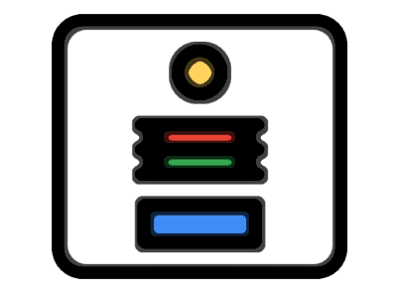
Most websites that allow a user to sign up and contribute information have a profile page for each user. This application is no different. In this tutorial what we want to do is allow users of the website to click on a user name in the browser, and see more information about that user on their profile page. We’ll setup a basic profile page feature with supporting test cases in our code to make sure it works well. As with the prior tutorials, we will let the results of running our tests direct us on what the next steps to take are when building out the profile page for our users.

Create a User Profile Test
Navigating to the Feature folder of our application, we can add a new Test Class named ProfilesTest. Then go ahead and add the boilerplate for a new test.
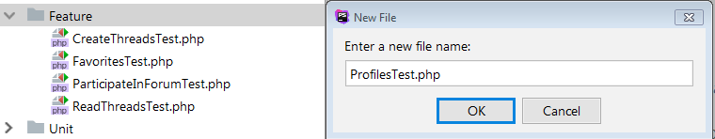


Create The Test Pseudocode
- Given we have a user in the application
- When we visit the profile / their name
- Then we should see their name on the page
Ok sounds reasonable enough. Let’s translate that into a test method and associated code.

<?php

namespace TestsFeature;

use IlluminateFoundationTestingDatabaseMigrations;
use TestsTestCase;
use IlluminateFoundationTestingWithFaker;
use IlluminateFoundationTestingRefreshDatabase;

class ProfilesTest extends TestCase
{
use DatabaseMigrations;

public function test_a_user_has_a_profile()
{
$user = create('AppUser');

$this->withoutExceptionHandling()->get('/profiles/' . $user->name)
->assertSee($user->name);
}
}
PHP
Let’s start running the test, and letting the errors direct us on the next steps to take.
vagrant@homestead:~/Code/forumio$ phpunit --filter test_a_user_has_a_profile
PHPUnit 6.5.5 by Sebastian Bergmann and contributors.

E 1 / 1 (100%)

Time: 947 ms, Memory: 8.00MB

There was 1 error:

1) TestsFeatureProfilesTest::test_a_user_has_a_profile
SymfonyComponentHttpKernelExceptionNotFoundHttpException: GET http://localhost/profiles/Athena Zulauf

/home/vagrant/Code/forumio/vendor/laravel/framework/src/Illuminate/Foundation/Testing/Concerns/InteractsWithExceptionHandling.php:107
/home/vagrant/Code/forumio/vendor/laravel/framework/src/Illuminate/Foundation/Http/Kernel.php:326
/home/vagrant/Code/forumio/vendor/laravel/framework/src/Illuminate/Foundation/Http/Kernel.php:120
/home/vagrant/Code/forumio/vendor/laravel/framework/src/Illuminate/Foundation/Testing/Concerns/MakesHttpRequests.php:345
/home/vagrant/Code/forumio/vendor/laravel/framework/src/Illuminate/Foundation/Testing/Concerns/MakesHttpRequests.php:168
/home/vagrant/Code/forumio/tests/Feature/ProfilesTest.php:18

ERRORS!
Tests: 1, Assertions: 0, Errors: 1.
We are getting a NotFoundHttpException which of course means there is no route to support that request.

Add the necessary route
Open the web.php routes file, and let’s add the route we need as highlighted here. When a user makes a request to /profiles/the user, then the show() method of the ProfilesController should trigger.
<?php

Route::get('/', function () {
return view('welcome');
});

Auth::routes();

Route::get('/home', 'HomeController@index')->name('home');

Route::get('/threads', 'ThreadsController@index');
Route::get('/threads/create', 'ThreadsController@create');
Route::get('/threads/{channel}/{thread}', 'ThreadsController@show');
Route::post('/threads', 'ThreadsController@store');
Route::get('/threads/{channel}', 'ThreadsController@index');
Route::post('/threads/{channel}/{thread}/replies', 'RepliesController@store');
Route::post('/replies/{reply}/favorites', 'FavoritesController@store');
Route::get('/profiles/{user}', 'ProfilesController@show');
PHP
Run the test again to see what the error is.
vagrant@homestead:~/Code/forumio$ phpunit --filter test_a_user_has_a_profile
PHPUnit 6.5.5 by Sebastian Bergmann and contributors.

E 1 / 1 (100%)

Time: 960 ms, Memory: 8.00MB

There was 1 error:

1) TestsFeatureProfilesTest::test_a_user_has_a_profile
ReflectionException: Class AppHttpControllersProfilesController does not exist
The test gives an error that the ProfilesController does not exist. This does make sense of course, since we have not yet created the controller we need to support profiles.

Create A ProfilesController Class
We can quickly create a new controller with this snippet.
vagrant@homestead:~/Code/forumio$ php artisan make:controller ProfilesController
Controller created successfully.
Since we now have a ProfilesController in place, that error should be fixed in the test. Let’s test again.
vagrant@homestead:~/Code/forumio$ phpunit --filter test_a_user_has_a_profile
PHPUnit 6.5.5 by Sebastian Bergmann and contributors.

E 1 / 1 (100%)

Time: 918 ms, Memory: 8.00MB

There was 1 error:

1) TestsFeatureProfilesTest::test_a_user_has_a_profile
BadMethodCallException: Method [show] does not exist on [AppHttpControllersProfilesController].
Now we are getting a BadMethodCallException. Makes sense of course, since there is no show() method on the controller.

Create a show() method
Now we can add the show() method to the ProfilesController class. Here we go:
<?php

namespace AppHttpControllers;

use IlluminateHttpRequest;

class ProfilesController extends Controller
{
public function show()
{

}
}
PHP
The show method does exist now. It doesn’t do anything yet, but let’s run our test to see what the message is now.
vagrant@homestead:~/Code/forumio$ phpunit --filter test_a_user_has_a_profile
PHPUnit 6.5.5 by Sebastian Bergmann and contributors.

F 1 / 1 (100%)

Time: 881 ms, Memory: 8.00MB

There was 1 failure:

1) TestsFeatureProfilesTest::test_a_user_has_a_profile
Failed asserting that '' contains "Forrest Treutel".

/home/vagrant/Code/forumio/vendor/laravel/framework/src/Illuminate/Foundation/Testing/TestResponse.php:236
/home/vagrant/Code/forumio/tests/Feature/ProfilesTest.php:19

FAILURES!
Tests: 1, Assertions: 1, Failures: 1.
Looks like our good friend Forrest Treutel is not being seen on the page when we visit his profile. Let’s fix up that show() method to fix this error.
<?php

namespace AppHttpControllers;

use IlluminateHttpRequest;

class ProfilesController extends Controller
{
public function show()
{
return view('profiles.show');
}
}
PHP

Create A View For User Profiles
The show.blade.php for profiles does not yet exist, so we need to create that. Just for grins, let’s confirm that with our test.
vagrant@homestead:~/Code/forumio$ phpunit --filter test_a_user_has_a_profile
PHPUnit 6.5.5 by Sebastian Bergmann and contributors.

E 1 / 1 (100%)

Time: 861 ms, Memory: 8.00MB

There was 1 error:

1) TestsFeatureProfilesTest::test_a_user_has_a_profile
InvalidArgumentException: View [profiles.show] not found.
Yep. The view profiles.show is not found. Let’s create that view.
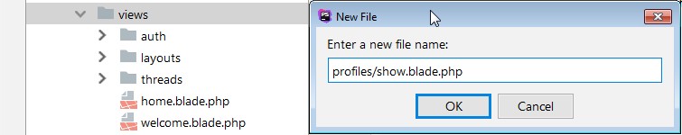
We’ll start with this basic markup.
@extends('layouts.app')

@section('content')
{{ $profileUser->name }}
@endsection
Markup
Let’s give that test another whirl.
vagrant@homestead:~/Code/forumio$ phpunit --filter test_a_user_has_a_profile
PHPUnit 6.5.5 by Sebastian Bergmann and contributors.

E 1 / 1 (100%)

Time: 1.26 seconds, Memory: 10.00MB

There was 1 error:

1) TestsFeatureProfilesTest::test_a_user_has_a_profile
ErrorException: Undefined variable: profileUser (View: /home/vagrant/Code/forumio/resources/views/profiles/show.blade.php)
It looks like we have an undefined variable. We need to pass data to the view to fix this. To do this, we can update the show() method in the ProfilesController like so.
<?php

namespace AppHttpControllers;

use IlluminateHttpRequest;

class ProfilesController extends Controller
{
public function show(User $user)
{
return view('profiles.show', [
'profileUser' => $user
]);
}
}
PHP
Now that we are sharing our variable, we can run the test to see if we fixed it.
vagrant@homestead:~/Code/forumio$ phpunit --filter test_a_user_has_a_profile
PHPUnit 6.5.5 by Sebastian Bergmann and contributors.

E 1 / 1 (100%)

Time: 911 ms, Memory: 8.00MB

There was 1 error:

1) TestsFeatureProfilesTest::test_a_user_has_a_profile
IlluminateDatabaseEloquentModelNotFoundException: No query results for model [AppUser].
So we fixed the previous error, but now we are getting a ModelNotFoundException. The reason is in how Route Model Binding is configured by default.

Configuring Route Model Binding Route Key
If we want the Model to make use of a slug, like we are doing here, then we need to configure the getRouteKeyName() method to support this. Go ahead and open up the User Model, and we can make this adjustment.
<?php

namespace App;

use IlluminateNotificationsNotifiable;
use IlluminateFoundationAuthUser as Authenticatable;

class User extends Authenticatable
{
use Notifiable;

protected $fillable = [
'name', 'email', 'password',
];

protected $hidden = [
'password', 'remember_token',
];

public function getRouteKeyName()
{
return 'name';
}
}
PHP
Once again, let’s run the test. Yahoo!! Look at that GREEN!
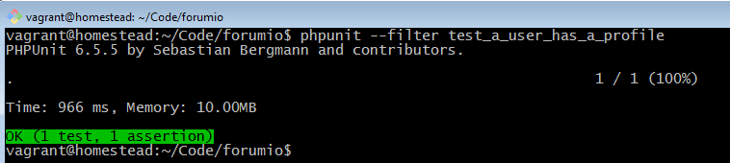
This means that if we were to visit a profile page in the Browser, it should actually work at this point. There just so happens to be a user in the system named “Tom” so let’s visit http://forum.io/profiles/tom and see what we get.
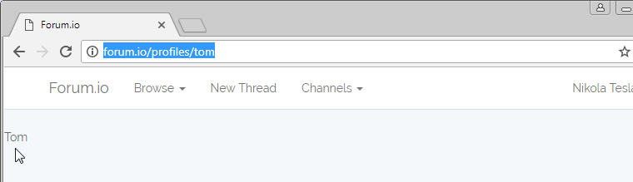

Better Styling With Bootstrap
So we see the user name on the page, and we’re not exactly blown away by the design. The logic of the page works just fine, but we want to make things look a little more pleasing. We can update the show.blade.php view to something like this:
@extends('layouts.app')

@section('content')
<div class="container">
<div class="page-header">
<h1>
{{ $profileUser->name }}
<small>registered {{ $profileUser->created_at->diffForHumans() }}</small>
</h1>
</div>
</div>
@endsection
Markup
which gives a little nicer profile layout.
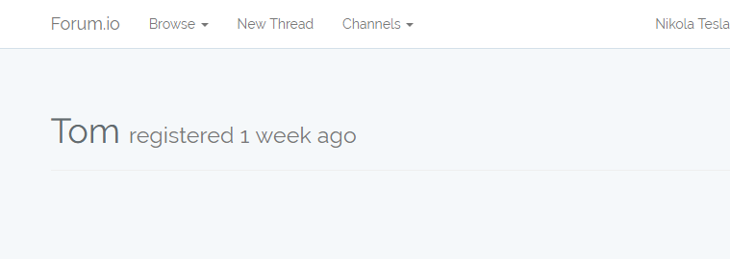

Displaying Threads A User Has Created
One feature we would like to add is the ability to view all threads created by the user who’s profile you are viewing. In order to add this feature, we will once again build out a test first to support it. In the ProfilesTest class, we can add a new test method of test_profiles_display_all_threads_by_the_user(). Now let’s think of what we want the test to accomplish.
- Given we have a user
- Given we have a thread created by that user
- When we visit their profile page
- Then we should see their thread
Here is some test code that approximates these steps.
<?php

namespace TestsFeature;

use IlluminateFoundationTestingDatabaseMigrations;
use TestsTestCase;
use IlluminateFoundationTestingWithFaker;
use IlluminateFoundationTestingRefreshDatabase;

class ProfilesTest extends TestCase
{
use DatabaseMigrations;

public function test_a_user_has_a_profile()
{
$user = create('AppUser');

$this->withoutExceptionHandling()->get('/profiles/' . $user->name)
->assertSee($user->name);
}

public function test_profiles_display_all_threads_by_the_user()
{
$user = create('AppUser');

$thread = create('AppThread', ['user_id' => $user->id]);

$this->withoutExceptionHandling()->get('/profiles/' . $user->name)
->assertSee($thread->title)
->assertSee($thread->body);
}
}
PHP
With our test in place we can trigger it to run and observe the results.
vagrant@homestead:~/Code/forumio$ phpunit --filter test_profiles_display_all_threads_by_the_user
PHPUnit 6.5.5 by Sebastian Bergmann and contributors.

F 1 / 1 (100%)

Time: 1.22 seconds, Memory: 10.00MB

There was 1 failure:

1) TestsFeatureProfilesTest::test_profiles_display_all_threads_by_the_user
Failed asserting that '(the html)' contains "Alias autem velit atque sit aspernatur.".

/home/vagrant/Code/forumio/vendor/laravel/framework/src/Illuminate/Foundation/Testing/TestResponse.php:236
/home/vagrant/Code/forumio/tests/Feature/ProfilesTest.php:29

FAILURES!
Tests: 1, Assertions: 1, Failures: 1.
The test is failing because the title of the thread is actually not appearing on the profile page. We need to build out the code that actually makes that happen. We can add this block of markup to show.blade.php to display the threads of the user.
@extends('layouts.app')

@section('content')
<div class="container">
<div class="page-header">
<h1>
{{ $profileUser->name }}
<small>registered {{ $profileUser->created_at->diffForHumans() }}</small>
</h1>
</div>

@foreach($profileUser->threads as $thread)
<div class="panel panel-default">
<div class="panel-heading">
<a href="#">{{ $thread->creator->name }}</a> posted:
{{ $thread->title }}
</div>
<div class="panel-body">
{{ $thread->body }}
</div>
</div>
@endforeach
</div>
@endsection
Markup
Once again, we will run our test to see how it works.
vagrant@homestead:~/Code/forumio$ phpunit --filter test_profiles_display_all_threads_by_the_user
PHPUnit 6.5.5 by Sebastian Bergmann and contributors.

E 1 / 1 (100%)

Time: 835 ms, Memory: 10.00MB

There was 1 error:

1) TestsFeatureProfilesTest::test_profiles_display_all_threads_by_the_user
ErrorException: Invalid argument supplied for foreach() (View: /home/vagrant/Code/forumio/resources/views/profiles/show.blade.php)
The error is complaining of an invalid argument being passed to the foreach loop. Well, that makes sense actually since we did not yet create the threads relationship on the User Model. We can add that right now. Also note that we add the latest() method to the relation definition so that we we are viewing the user’s threads, the most recent threads appear at the top of the page.
<?php

namespace App;

use IlluminateNotificationsNotifiable;
use IlluminateFoundationAuthUser as Authenticatable;

class User extends Authenticatable
{
use Notifiable;

protected $fillable = [
'name', 'email', 'password',
];

protected $hidden = [
'password', 'remember_token',
];

public function getRouteKeyName()
{
return 'name';
}

public function threads()
{
return $this->hasMany(Thread::class)->latest();
}
}
PHP
Running our test shows that it is now passing.
vagrant@homestead:~/Code/forumio$ phpunit --filter test_profiles_display_all_threads_by_the_user
PHPUnit 6.5.5 by Sebastian Bergmann and contributors.

. 1 / 1 (100%)

Time: 892 ms, Memory: 10.00MB

OK (1 test, 2 assertions)
When we now visit our sample user Tom’s profile page at http://forum.io/profiles/tom, we do see a recent thread that he created! So it looks like viewing threads on the user’s profile page is now good to go.
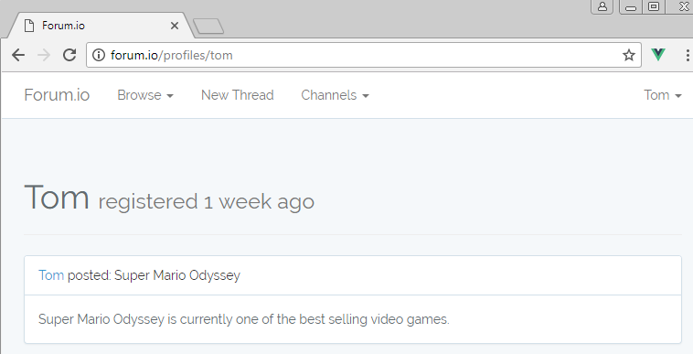

Paginating Threads On User Profile Page
As users spend more time posting threads on the application, they may amass hundreds and hundreds of threads created. We should paginate these on the profile page instead of trying to load all of them in one shot. This is easy to set up in the show() method of the ProfilesController, as well as the associated view file with a call to $threads->links().
Updating the controller
<?php

namespace AppHttpControllers;

use AppUser;
use IlluminateHttpRequest;

class ProfilesController extends Controller
{
public function show(User $user)
{
return view('profiles.show', [
'profileUser' => $user,
'threads' => $user->threads()->paginate(1)
]);
}
}
PHP
Updating the view
@extends('layouts.app')

@section('content')
<div class="container">
<div class="page-header">
<h1>
{{ $profileUser->name }}
<small>registered {{ $profileUser->created_at->diffForHumans() }}</small>
</h1>
</div>

@foreach($threads as $thread)
<div class="panel panel-default">
<div class="panel-heading">
<div class="level">
<span class="flex">
<a href="#">{{ $thread->creator->name }}</a> posted:
{{ $thread->title }}
</span>
<span>{{$thread->created_at->diffForHumans()}}</span>
</div>
</div>
<div class="panel-body">
{{ $thread->body }}
</div>
</div>
@endforeach
{{ $threads->links() }}
</div>
@endsection
Markup
Now the pagination is working nicely. We set it to only 1 at this point just to demonstrate. Maybe you could bump it up to 20 or 30 in the real application.
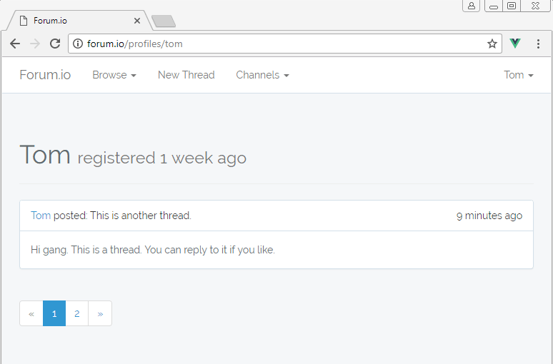

Linking User Names To Their Profile Page
At this point the user names displayed in our view files do not link anywhere. Let’s update that so that users can click on a user name in the browser, and be brought to their profile page.
In show.blade.php you can swap instances of the first link with the second link.

<a href="#">{{ $thread->creator->name }}</a>

<a href="/profiles/{{ $thread->creator->name }}">{{ $thread->creator->name }}</a>
Markup
In reply.blade.php you can swap you can swap instances of the first link with the second link.

<a href="#">{{$reply->owner->name}}</a>

<a href="/profiles/{{ $reply->owner->name }}">{{$reply->owner->name}}</a>
Markup
Now all the instances of a user name in the browser link back to the user’s profile.

Making Use Of Named Routes
One other option you have in this case is to set up a named route if you like. This way you can use the named route in the href of your anchor tags of the view files. How does this work? Well first off, we need to assign a name to the route in question. We do this in our routes file with the example highlighted here. We are naming this route ‘profile’.

<?php

Route::get('/', function () {
return view('welcome');
});

Auth::routes();

Route::get('/home', 'HomeController@index')->name('home');

Route::get('/threads', 'ThreadsController@index');
Route::get('/threads/create', 'ThreadsController@create');
Route::get('/threads/{channel}/{thread}', 'ThreadsController@show');
Route::post('/threads', 'ThreadsController@store');
Route::get('/threads/{channel}', 'ThreadsController@index');
Route::post('/threads/{channel}/{thread}/replies', 'RepliesController@store');
Route::post('/replies/{reply}/favorites', 'FavoritesController@store');
Route::get('/profiles/{user}', 'ProfilesController@show')->name('profile');
PHP
The nice thing about named routes is that you can continue to use the regular links as we have already configured. Additionally however, we can format our links using the name of the route like we see here.
In show.blade.php you can swap instances of the first link with the second link.
<a href="/profiles/{{ $thread->creator->name }}">
<a href="{{ route('profile', $thread->creator) }}">
Markup
In reply.blade.php you can swap instances of the first link with the second link.
<a href="/profiles/{{ $reply->owner->name }}">
<a href="{{ route('profile', $reply->owner) }}">
Markup

How To Create User Profiles In Your Application Summary
What a great tutorial we had here! There were a lot of steps to take in getting our user profile page for users set up and working correctly. Thankfully, we took our time and got everything working nicely.
https://vegibit.com/how-to-create-user-profiles-in-your-application/

Updating Laravel 8 User profile information using bootstrap livewire and fortify
#bootstrap #laravel #livewire #fortify
 Jasmine Tracey ・4 min read
In part one of this article, we created our authentication setup using fortify, laravel and bootstrap.


Laravel 8 authentication with Bootstrap and Fortify

Jasmine Tracey ・ Oct 10 '20 ・ 3 min read
#laravel #fortify #bootstrap #auth
In this tutorial, We will cover:
- updating your profile information using livewire
- changing your password from your profile page using livewire

Clone part one of our project
git clone --branch starter git@github.com:jasminetracey/lara8auth.git
cd lara8auth
Open your newly created project in IDE of choice I will be using Visual Studio Code

Install Livewire
composer require livewire/livewire
Next, we will load livewire assets in our layout files:
...

<!-- Styles -->
<link href="{{ asset('css/app.css') }}" rel="stylesheet">

<livewire:styles />

...

<livewire:scripts />

</body>
</html>
also, we will publish the config file php artisan livewire:publish --config

Create profile page
Add profile page touch resources/views/profile.blade.php
After doing that we will add a route in our routes/web.php file so that we can access the page.
Route::middleware(['auth', 'verified'])->group(function () {
Route::view('home', 'home')->name('home');

Route::view('profile','profile')->name('profile');
});
Now we will update our navbar section in our resources/layouts/app.blade.php file so will we have a visible link to navigate to our page.

@else
<li class="nav-item {{ request()->routeIs('home') ? 'active' : '' }}">
<a class="nav-link" href="{{ route('home') }}">{{ __('Home') }}</a>
</li>
<li class="nav-item {{ request()->routeIs('profile') ? 'active' : '' }}">
<a class="nav-link" href="{{ route('profile') }}">{{ __('Profile') }}</a>
</li>

Create livewire profile information form
If you are are new to livewire Caleb the creator of laravel-livewire have created some tutorial videos here to get you started
From your terminal run the following command
php artisan livewire:make profile-form
This will create our first livewire component.
In your resources/views/livewire/profile-form.blade.php add the following code to create our form fields.
<section class="my-5">
@if (session()->has('status'))
<div class="alert alert-success alert-dismissible fade show" role="alert">
{{ session('status') }}
<button type="button" class="close" data-dismiss="alert" aria-label="Close">
<span aria-hidden="true">&times;</span>
</button>
</div>
@endif

<div class="card">
<div class="card-body">
<h5 class="card-title">Update Profile Information</h5>

@if ($errors->any())
<div class="alert alert-danger">
<ul>
@foreach ($errors->all() as $error)
<li>{{ $error }}</li>
@endforeach
</ul>
</div>
@endif

<form wire:submit.prevent="updateProfileInformation" role="form">

<div class="form-group">
<label for="state.email">Name</label>
<input type="text" class="form-control" id="state.name" wire:model="state.name"/>
</div>

<div class="form-group">
<label for="state.email">Email Address</label>
<input type="email" class="form-control" id="state.email" wire:model="state.email"/>
</div>

<div class="form-group">
<button type="submit" class="btn btn-primary">Update Info</button>
</div>
</form>
</div>
</div>
</section>
After adding our view we need to add the code in the livewire component file app\Http\Livewire\ProfileForm.php to interact with fields.
We will first add a public array which will store the fields that we will interact with
public $state = [];
Then we will add the mount method. This is a function that runs when the component is populated. We will use this method to populate the state array.
public function mount()
{
$this->state = auth()->user()->withoutRelations()->toArray();
}
Next, we will add the updateProfileInformation method that will use the UpdateUserProfileInformation action that comes with Fortify.
public function updateProfileInformation(UpdateUserProfileInformation $updater)
{
$this->resetErrorBag();

$updater->update(auth()->user(), $this->state);

session()->flash('status', 'Profile successfully updated');
}
Remember to import the UpdateUserProfileInformation action
Finally, we will add our component to the resources/views/profile.blade.php page so that we can see the form when we visit the profile page.
@extends('layouts.app')

@section('content')

<div class="container">

<livewire:profile-form />

</div>
@endsection

Create livewire password change form
From your terminal run the following command
php artisan livewire:make password-change-form
This will create our livewire component.
In your resources/views/livewire/password-change-form.blade.php add the following code to create our form fields.
<section class="my-5">
@if (session()->has('status'))
<div class="alert alert-success alert-dismissible fade show" role="alert">
{{ session('status') }}
<button type="button" class="close" data-dismiss="alert" aria-label="Close">
<span aria-hidden="true">&times;</span>
</button>
</div>
@endif

<div class="card">
<div class="card-body">
<h5 class="card-title">Update Password</h5>

@if ($errors->any())
<div class="alert alert-danger">
<ul>
@foreach ($errors->all() as $error)
<li>{{ $error }}</li>
@endforeach
</ul>
</div>
@endif

<form wire:submit.prevent="updateProfileInformation" role="form">

<div class="form-group">
<label for="state.current_password">Current Password</label>
<input type="password" class="form-control" id="state.current_password" wire:model="state.current_password"/>
</div>

<div class="form-group">
<label for="state.password">New Password</label>
<input type="password" class="form-control" id="state.password" wire:model="state.password"/>
</div>

<div class="form-group">
<label for="state.password_confirmation">Confirm Password</label>
<input type="password" class="form-control" id="state.password_confirmation" wire:model="state.password_confirmation"/>
</div>

<div class="form-group">
<button type="submit" class="btn btn-primary">Change Password</button>
</div>
</form>
</div>
</div>
</section>
After adding our view we need to add the code in the livewire component file app/Http/Livewire/PasswordChangeForm.php to interact with fields.
We will first add a public array which will store the fields that we will interact with
public $state = [
'current_password' => '',
'password' => '',
'password_confirmation' => '',
];
Next, we will add the changePassword method that will use the UpdateUserPassword action that comes with Fortify.
public function updateProfileInformation(UpdateUserPassword $updater)
{
$this->resetErrorBag();

$updater->update(auth()->user(), $this->state);

$this->state = [
'current_password' => '',
'password' => '',
'password_confirmation' => '',
];

session()->flash('status', 'Password successfully changed');
}
Remember to import the UpdateUserPassword action
Finally, we will add our component to the resources/views/profile.blade.php page so that we can see the form when we visit the profile page.
@extends('layouts.app')

@section('content')

<div class="container">

<livewire:profile-form />

<livewire:password-change-form/>

</div>
@endsection
Now when you go to /profile you should have two working forms for updating user info and changing their password.

Conclusion
To find out more about laravel fortify features you can go the the github respository Fortify and for livewire documentation you can go to livewire
Thanks for reading please comment below and share if you found this article helpful.
https://dev.to/jasminetracey/updating-laravel-8-user-profile-information-using-bootstrap-livewire-and-fortify-1cdo

Profile Management
- Introduction
- Actions
- Views / Pages
- Profile Photos
  - Enabling Profile Photos
  - Managing Profile Photos
- Account Deletion

# Introduction
Laravel Jetstream's profile management features are accessed by the user using the top-right user profile navigation dropdown menu. Jetstream scaffolds views and actions that allow the user to update their name, email address, and, optionally, their profile photo.
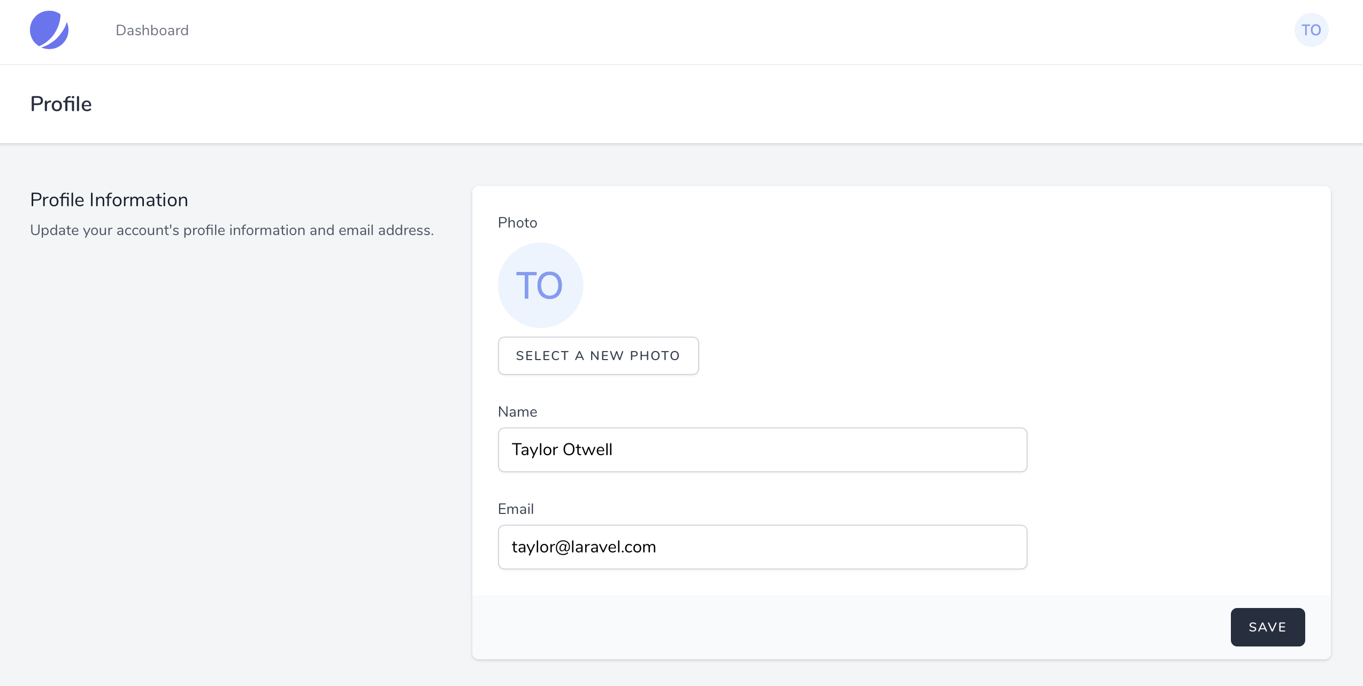

# Actions
As typical of most Jetstream features, the logic executed to satisfy profile update requests can be found in an action class within your application. Specifically, the App\Actions\Fortify\UpdateUserProfileInformation class will be invoked when the user updates their profile. This action is responsible for validating the input and updating the user's profile information.
Therefore, any customizations you wish to make to your application's management of this information should be made in this class. When invoked, the action receives the currently authenticated $user and an array of $input that contains all of the input from the incoming request, including the updated profile photo if applicable.
Managing Additional Information
If you need to manage additional information about the user, do not feel obligated to add additional to the "Profile Information" card within your Jetstream application's UI. You are free to add additional UI elements and forms to user's profile dashboard that are specific to the information you wish to manage.

# Views / Pages
When using the Livewire stack, the user's profile information form is displayed using the resources/views/profile/update-profile-information-form.blade.php Blade template. When using the Inertia stack, this view is displayed using the resources/js/Pages/Profile/UpdateProfileInformationForm.vue template.
Each of these templates will receive the entire authenticated user object so that you can add additional fields to these forms as necessary. Any additional inputs added to the forms will be included in the $input array that is passed to your UpdateUserProfileInformation action.

# Profile Photos

# Enabling Profile Photos
If you wish to allow users to upload custom profile photos, you must enable the feature in your application's config/jetstream.php configuration file. To enable the feature, simply uncomment the corresponding feature entry from the features configuration item within this file:
use Laravel\Jetstream\Features;

'features' => [
Features::profilePhotos(),
Features::api(),
Features::teams(),
],
After enabling the profile photo feature, you should execute the storage:link Artisan command. This command will create a symbolic link in your application's public directory that will allow your user's images to be served by your application. For information regarding this command, please consult the Laravel filesystem documentation
:
php artisan storage:link

# Managing Profile Photos
Jetstream's profile photo functionality is supported by the Laravel\Jetstream\HasProfilePhoto trait that is automatically attached to your App\Models\User class during Jetstream's installation.
This trait contains methods such as updateProfilePhoto, getProfilePhotoUrlAttribute, defaultProfilePhotoUrl, and profilePhotoDisk which may all be overwritten by your own App\Models\User class if you need to customize their behavior. You are encouraged to read through the source code of this trait so that you have a full understanding of the features it is providing to your application.
The updateProfilePhoto method is the primary method used to store profile photos and is called by your application's App\Actions\Fortify\UpdateUserProfileInformation action class.
Laravel Vapor
By default, the s3 disk will be used to store profile photos when your Jetstream application is running within Laravel Vapor
.

# Account Deletion
The profile management screen also includes an action panel that allows the user to delete their application account. When the user chooses to delete their account, the App\Actions\Jetstream\DeleteUser action class will be invoked. You are free to customize your application's account deletion logic within this class.
The account deletion feature may be disabled by removing the feature from your application's config/jetstream.php configuration file:
use Laravel\Jetstream\Features;

'features' => [
Features::termsAndPrivacyPolicy(),
Features::profilePhotos(),
Features::api(),
Features::teams(),
// Features::accountDeletion(),
],
https://jetstream.laravel.com/2.x/features/profile-management.html

Foro no perfil não aparece

Make sure the APP_URL is correct in your .env file including port. ie. if you are running on localhost and port 8000 your APP_URL should be APP_URL=http://127.0.0.1:8000.
If the profile photo is stored successfully and that didn't work try:
- Deleting the shortcut folder storage created at /project/public/
- run php artisan storage:link
The photo should show up.

Autenticação com Jetstream no Laravel 8
novidades jetstream laravel-8
Autenticação é um processo necessário em praticamente todo tipo de aplicação web. Neste post vamos entender como funciona o cadastro e autenticação de usuários utilizando o Laravel 8 e Jetstream.
Caso ainda não conheça o Laravel Jetstream recomendo dar um pulo no post conhecendo o Laravel Jetstream, lá comentei sobre o que é este pacote, dou um passo-a-passo de como fazer sua instalação e faço um review de suas funcionalidades de maneira geral.
Caso queira dar uma olhada em todo código utilizado neste post, preparei um repositório no github e criei um branch específico chamado autenticacao-jetstream.

Introdução
O Laravel Jetstream foi uma adição super interessante para a última versão do framework e o Laravel não cansa de nos surpreender. Com a chegada do Jetstream também tivemos novidades quanto a gerenciamento de usuários e autenticação no geral.
O Jetstream nos provê, de forma automática, funcionalidades como login, cadastro de usuários, verificação por email, reset de senhas e autenticação em dois fatores.
Vamos entender como funcionam cada um destes pontos e aprender como podemos customizá-los para atender nossas necessidades.

Estrutura das funcionalidades
Basicamente a estrutura das funcionalidades que vamos aprender daqui pra frente está separada em dois pontos: views (frontend) e actions (backend). O Laravel Jetstream é o cara que cuidará das views enquanto para as actions será utilizado um outro pacote, o Laravel Fortify .
Mas não se preocupe, não será necessário instalar mais nada! O Laravel Fortify vem instalado e pré configurado pra gente junto com o Jetstream.
Para facilitar vou separar este guia em dois: vamos começar falando sobre as views que o Jetstream criou pra gente e posteriormente vamos brincar um pouco com as actions e algumas configurações referentes ao Laravel Fortify.

Views
Um ponto bacana por parte da equipe do Laravel é que na criação da parte de autenticação foram utilizadas views “tradicionais” baseadas na Blade Template Engine, isso se torna muito interessante pois independente se escolhemos entre utilizar o Livewire ou Inertia como frontend, as views estão agnósticas e não foram baseadas em nenhum framework js.
As views referentes a autenticação podem ser encontradas no diretório resources/views/auth e sua estrutura é basicamente esta:
auth/
├── forgot-password.blade.php
├── login.blade.php
├── register.blade.php
├── reset-password.blade.php
├── two-factor-challenge.blade.php
└── verify-email.blade.php
Os nomes dos arquivos são bem sugestivos e cada um se refere a uma funcionalidade que o Jetstream provê para nós.
TL;DR;
Caso esteja acompanhando esta série utilizando o repositório do github, recomendo que neste momento você execute a aplicação e navegue por algumas dessas funcionalidades. Com exceção da autenticação em dois fatores e verificação por email, todas as outras funcionalidades podem ser acessadas sem precisar criar um cadastro prévio ou realizar configurações adicionais.

Colocando a aplicação para rodar
Vamos colocar a aplicação para rodar e visualizar a página de registro de usuários. Vamos utilizar o servidor embutido do PHP na porta 8000 e apontá-lo para a pasta public/, a partir da raiz do projeto execute o seguinte comando:
php -S 127.0.0.1:8000 -t public/
Caso esteja utilizando o docker-compose provido no repositório desta série, basta seguir os passos do README do repositório e executar o comando:
docker-compose up -d
Agora que nossa aplicação está funcionando podemos acessar a página de cadastro (/register). Caso esteja utilizando o docker provido e tenha seguido os passos iniciais basta acessar a url jetstream.test/register , caso esteja utilizando o servidor embutido do PHP acesse localhost:8000/register. Neste momento temos uma página como esta:

Customizando as views
No post anterior já fizemos uma customização em um componente utilizado por esta view quando alteramos o logo da aplicação. Desta vez vamos alterar a view principal ao invés de um componente específico.
Vamos assumir que para esta aplicação apenas o campo name não é suficiente pra gente, queremos separar o nome do usuário em dois campos: name e surname (nome e sobrenome). As views criadas na instalação do Jetstream nos permite esse tipo de alteração, veja como é fácil: vamos alterar o arquivo resources/views/register.blade.php no seguinte trecho
//...
<form method="POST" action="{{ route('register') }}">
@csrf
<div>
<x-jet-label value="{{ __('Name') }}" />
<x-jet-input class="block mt-1 w-full" type="text" name="name" :value="old('name')"
required autofocus autocomplete="name" />
</div>
//...
Vamos adicionar o campo surname logo após o fechamento da div referente ao campo name
//...
<form method="POST" action="{{ route('register') }}">
@csrf

<div>
<x-jet-label value="{{ __('Name') }}" />
<x-jet-input class="block mt-1 w-full" type="text" name="name" :value="old('name')"
required autofocus autocomplete="name" />
</div>
<div class="mt-4">
<x-jet-label value="{{ __('Surname') }}" />
<x-jet-input class="block mt-1 w-full" type="text" name="surname" :value="old('surname')"
required autofocus autocomplete="surname" />
</div>
//...
Basta atualizar a página de registro (/register) e verificar o novo campo adicionado, a página deve se parecer com isto:

Fácil, não?! Claro que o exemplo que trouxe é muito simples mas a ideia é deixar claro que é simples modificarmos qualquer um dos formulários criados automaticamente de acordo com a nossa necessidade. Aqui utilizei a necessidade de separar o campo nome em dois como exemplo, mas poderia muito bem ser a adição de campos como gênero ou estado civil que são bastante comuns em formulários de cadastro, depende da necessidade de cada um e o importante é sabermos que não estamos presos a estrutura criada pelo framework.

Como mudar os caminhos das views
No passo anterior vimos como é fácil alterar os formulários gerados automaticamente pelo Jetstream, no exemplo alteramos o formulário de cadastro de usuários mas para alterar os demais formulários como login, recuperação de senha ou autenticação em dois fatores só precisamos utilizar suas respectivas views e customizar a vontade.
Mas e se por acaso já tivéssemos estes formulários prontos, seríamos obrigados a utilizar as views providas automaticamente? A resposta é simples: não!

Como alterar o diretório das views no Laravel Jetstream
Caso seja necessário alterar o caminho das views basta “ensinar” o Jetstream de onde ele deve carregá-las, desta forma podemos “plugar” views pré existentes ao restante do Jetstream.
Todas as views de autenticação podem ser alteradas utilizando métodos específicos da classe Laravel\Fortify\Fortify e para “ensinar” como o Jetstream deverá carregar uma view precisamos utilizar esta classe no método boot do provider JetstreamServiceProvider.
Ao invés de utilizar a view localizada em resources/views/auth/login.blade.php vamos criar uma nova view em resources/views/auth/custom-login.blade.php contendo o código a seguir:
<x-guest-layout>
<x-jet-authentication-card>
<x-slot name="logo">
<x-jet-authentication-card-logo />
</x-slot>

<x-jet-validation-errors class="mb-4" />

@if (session('status'))
<div class="mb-4 font-medium text-sm text-green-600">
{{ session('status') }}
{{ session('status') }}
</div>
@endif

<div class="w-full">
<form method="POST" action="{{ route('login') }}" class="bg-white px-8 pt-6 pb-8 mb-4">
@csrf

<div class="mb-4">
<label class="block text-gray-700 text-sm font-bold mb-2" for="email">
Email
</label>
<input class="shadow appearance-none border rounded w-full py-2 px-3 text-gray-700 leading-tight focus:outline-none focus:shadow-outline" id="email" type="email" name="email" required placeholder="example@laraveling.tech">
</div>
<div class="mb-6">
<label class="block text-gray-700 text-sm font-bold mb-2" for="password">
Password
</label>
<input class="shadow appearance-none border rounded w-full py-2 px-3 text-gray-700 mb-3 leading-tight focus:outline-none focus:shadow-outline" id="password" type="password" name="password" required placeholder="************">
</div>
<div class="flex items-center justify-between">
<button class="bg-blue-500 hover:bg-blue-700 text-white font-bold py-2 px-4 rounded focus:outline-none focus:shadow-outline" type="submit">
Log In
</button>
<a class="inline-block align-baseline font-bold text-sm text-blue-500 hover:text-blue-800" href="{{ route('password.request') }}">
Forgot Password?
</a>
</div>
</form>
<p class="text-center text-gray-500 text-xs">
&copy;2020 Laraveling. All rights reserved.
</p>
</div>
</x-jet-authentication-card>
</x-guest-layout>
Este é um formulário totalmente diferente do que foi provido automaticamente na instalação, nele estamos utilizando os estilos do Tailwind CSS que já vem instalado no Laravel 8. Agora basta “ensinar” o Jetstream como carregá-lo e podermos ver a mudança. Vamos alterar o método boot no provider JetstreamServiceProvider utilizando a classe Fortify citada anteriormente. Como a view que queremos alterar é a view de login, vamos utilizar o método Fortify::loginView(), este método recebe um callback onde podemos indicar o caminho para a nossa view de login
namespace App\Providers;

use Laravel\Fortify\Fortify;

public function boot()
{
Fortify::loginView(function () {
return view('auth.custom-login');
});
}
Agora basta acessar a página de login (/login) e teremos um formulário novinho em folha

Para alterar o caminho das demais views precisamos apenas utilizar os métodos correspondentes na classe Fortify, são eles: Fortify::registerView(), Fortify::twoFactorChallengeView(), Fortify::requestPasswordResetLinkView() e por aí vai. Lembrando que é necessário colocar estas alterações no método boot da classe JetstreamServiceProvider.
Para entender melhor quais métodos existem e como podem ser utilizados recomendo dar uma olhada na documentação no repositório do Laravel Fortify.

Conclusão
Agora já sabemos como alterar praticamente tudo referente ao frontend criado pelo Laravel Jetstream e podemos customizar a vontade para que a aplicação atenda nossas necessidades.
Para alterar as regras do backend como rotas de redirecionamento, lógicas de validações, regras de persistência, etc. Precisaremos mexer no “esqueleto” provisionado a partir das actions do Laravel Fortify mas este será assunto para um próximo post!
Para não perder as próximas publicações e nem a continuação desta série sobre o Laravel Jetstream você pode utilizar o feed json ou o feed atom em seu agregador favorito, desta forma você receberá uma notificação a cada post novo!
Fique de olho também na sessão de categorias, lá você poderá escolher uma categoria e ver os posts relacionados =)
https://laraveling.tech/autenticacao-jetstream-laravel-8/

